***Flixon***

1. Click the below link to open the home page:

<http://localhost/ulman/08/FlixonProject/index.php>

OR

index.html (from the folder)

1. Perform Authentication:

**Registration**:

Enter details such as:

* FirstName - Yash
* LastName - Khopkar
* UserName - kp
* Password - 1
* Confirm Password- 1

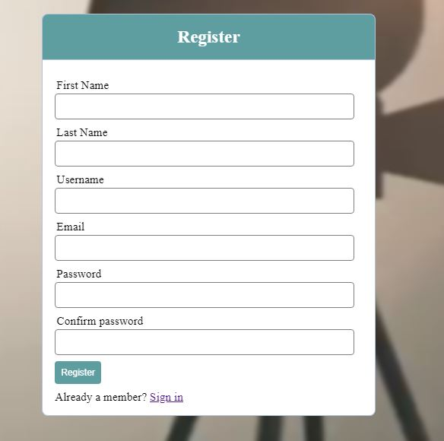

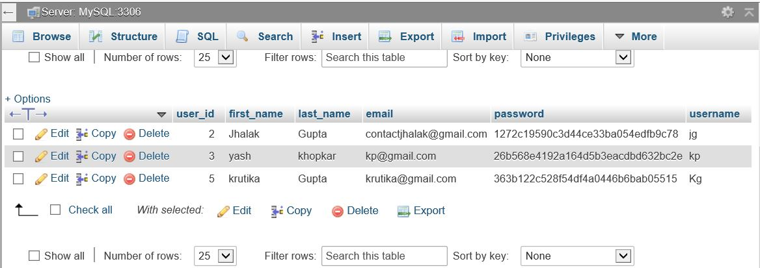

Press on Register button, you will be navigated to the below link:

<http://localhost/ulman/08/FlixonProject/Movie.php>

***Navigation through the project:***

1. HOME SCREEN – Click on “FLIXON” on the left-hand side top corner of the Nav bar to visit the home page from any other screen.

The home screen has Video Controller for playing a video in the background of the search bar as shown in the image below

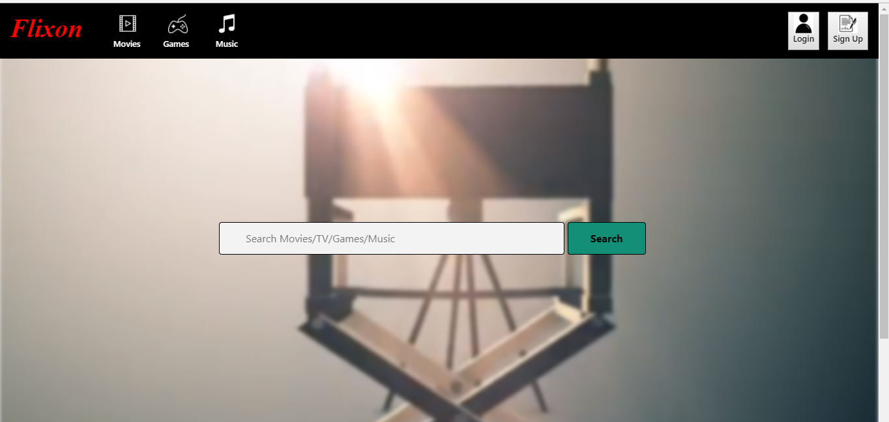

1. MOVIES SCREEN – Click on “Movies” icon on the Nav bar to navigate to the Movies section. To enter further screens in Movies, click on the dropdowns “List Of Movies” and “Flixon VS User Ratings” from the Movies icon.

This screen allows the user to scroll through the movies

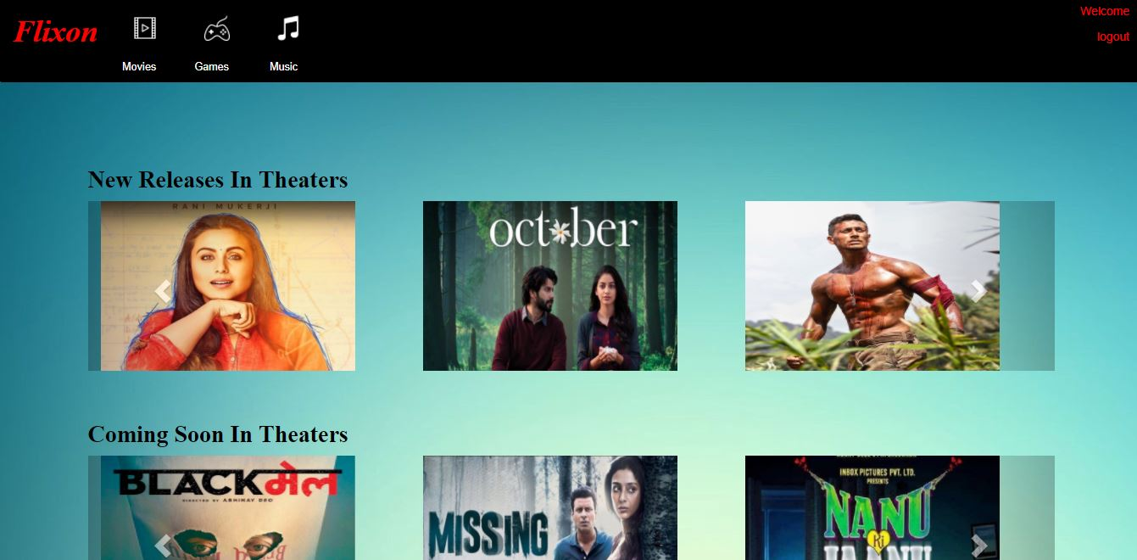

Then click on any movie to navigate to the movie details from either the movies icon or the dropdown “List Of Movies”.

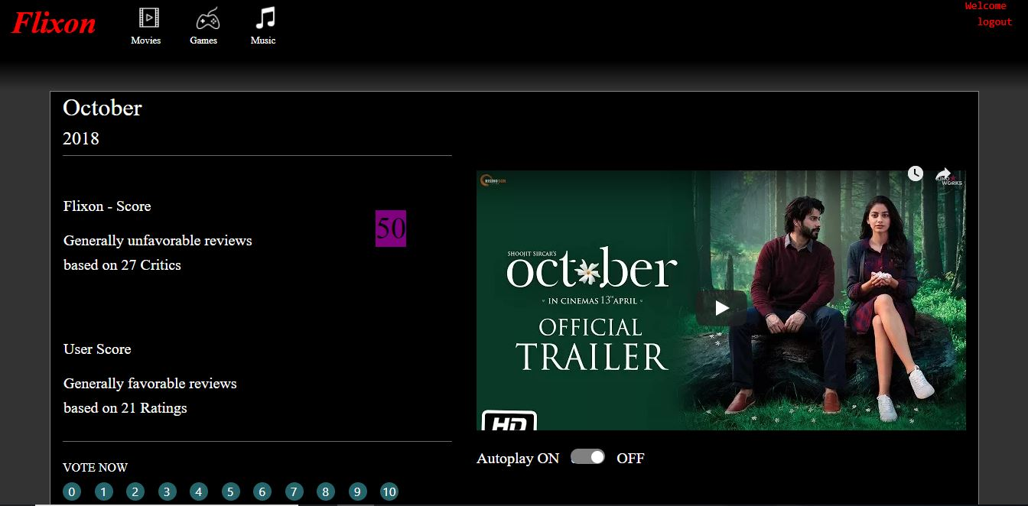

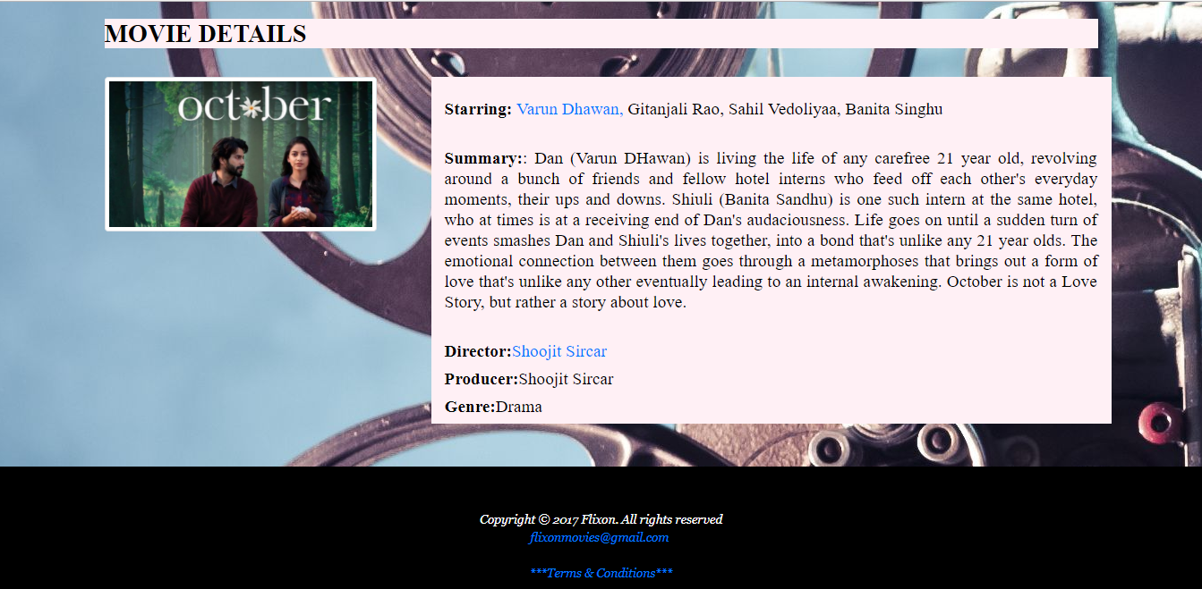

1. Then click on the dropdown “Flixon VS User Ratings” from the Movies icon.

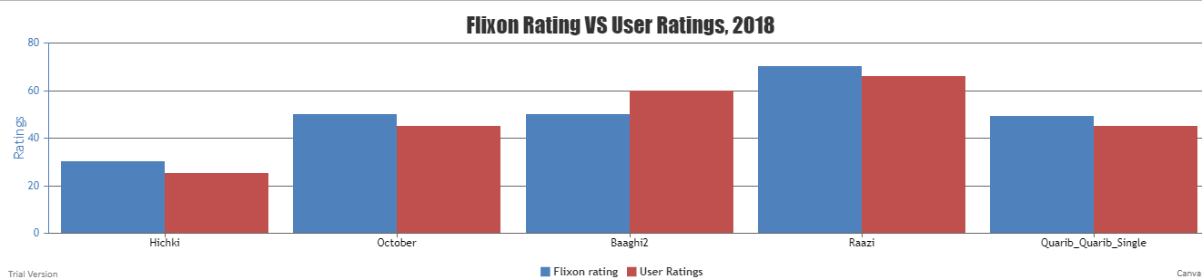

1. GAMES SCREEN – Click on “Games” icon on the Nav bar to navigate to the games screen. And then click on “FIND OUT MORE” button to view Games in detail.

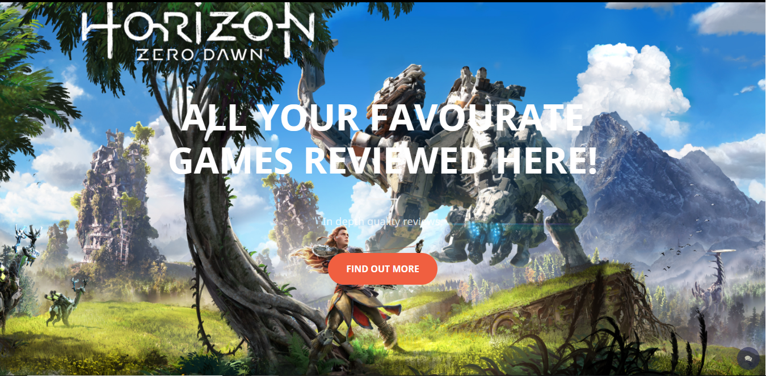

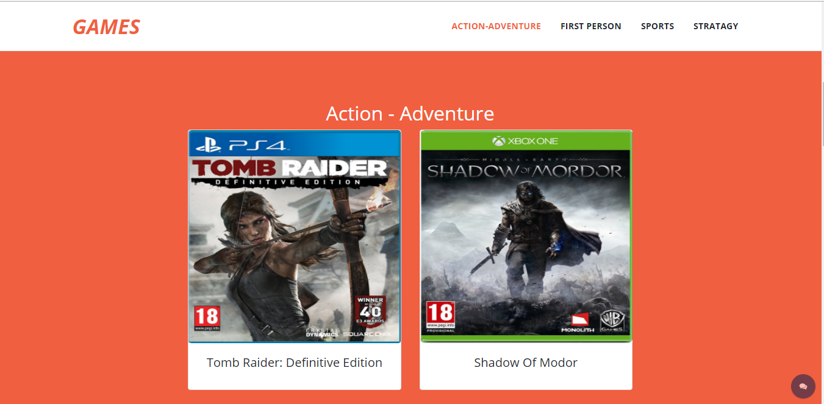

Click on any game and find its details and critics review.

1. On the above screen, click on the Chat icon on the right-hand side bottom corner.

A Chatbot will be opened. User can type messages and click on send to display conversation on the chat window.

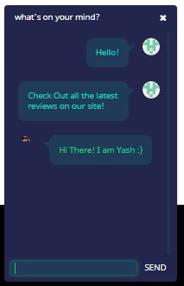

1. Share your thoughts by typing in the comments box and clicking on submit button.

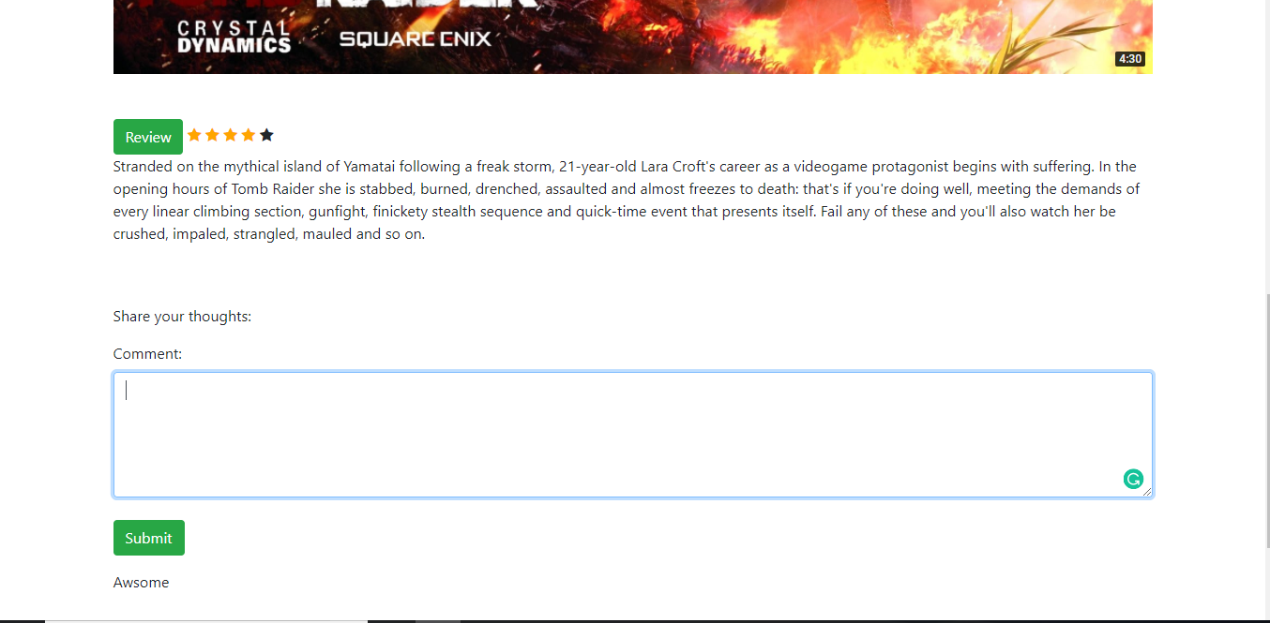

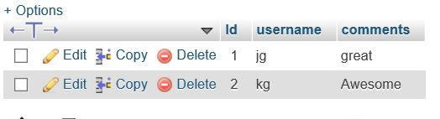

1. MUSIC SCREEN – Click on “Music” icon on the Nav bar to navigate to the music screen.

To enter further screens in Music, click on the dropdowns “Sort Songs by Name & Rating” and “Upcoming Music Events” from the Music icon.

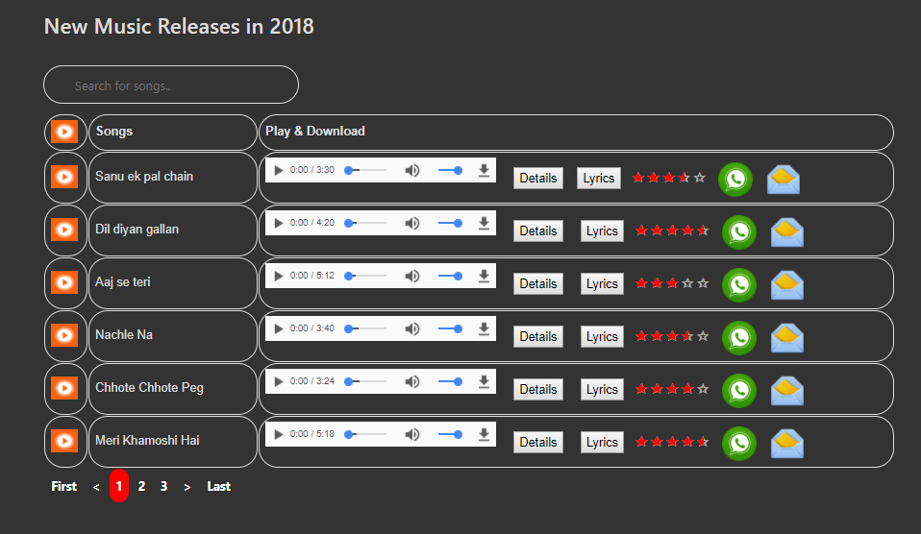

The above screen can be viewed by just clicking on the Music icon and scrolling down. User can find multiple functionalities on the same.

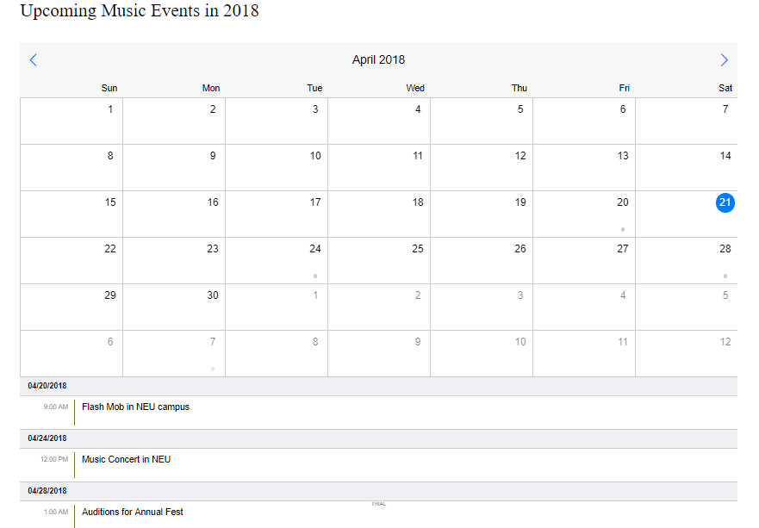

The above screen can be viewed by clicking on the dropdown “Upcoming Music Events” from the Music icon. User can find list of events in a calendar.

1. Then click on the dropdown “Sort Songs by Name & Rating” from the Music icon. User can find sorting of songs for name and rating by ascending and descending order.

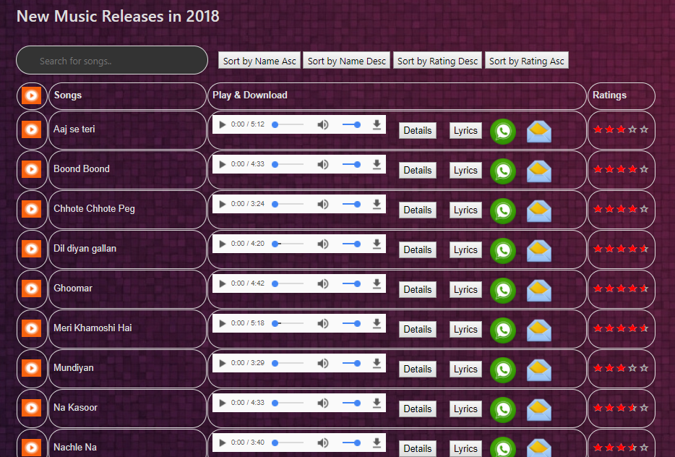

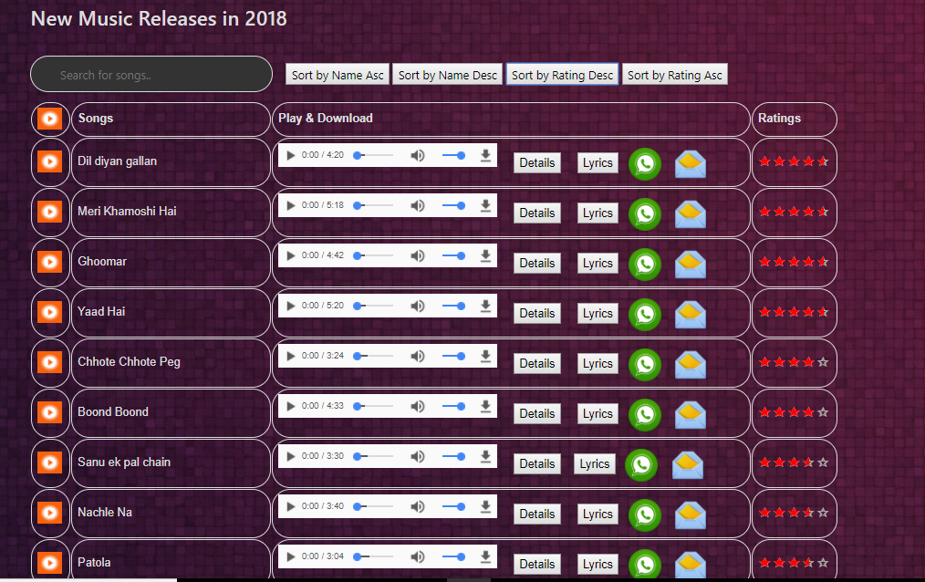

1. FOOTER- User can navigate to the footer at the bottom of each page.

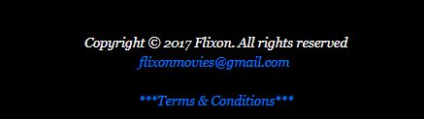

10) Terms and condition:

